**CS2040S: Data Structures and Algorithms**

Discussion Group Problems for Week 11

*For: March 31–April 4*

In this week’s tutorial, we will be focusing on:

* Shortest Paths
* Dijkstra’s Algorithm
* Directed Acyclic Graphs

**Problem 1.** (Bad Dijkstra)

**Problem 1.a.** Give an example of a graph where Dijkstra’s algorithm returns the wrong answer.

**Ans:** One example of a graph would be when the graph has negative weights.

**Problem 1.b.** Give examples of graphs where if we used Dijkstra’s algorithm, it would output the correct answer. And yet it would be unsuitable.

**Ans:** Using Dijkstra’s algorithm on a Tree. BFS/DFS is more efficient as compared to Dijkstra’s algorithm as BFS/DFS takes O(*V* + *E*) whereas Dijkstra’s algorithm would take O(*E $\log{V}$* ).

Another example would be using Dijkstra’s algorithm on a Directed Acyclic Graph (DAG). Doing toposort followed by Bellman Ford would be more efficient as it would have a time complexity of O(*V* + *E*) whereas using Dijkstra’s algorithm, the time complexity would be O(*E $\log{V}$* ).

**Problem 2.** (Pizza Pirate Encounters) Related Kattis Problems:

* <https://open.kattis.com/problems/arbitrage>
* <https://open.kattis.com/problems/getshorty>

Welcome to Mel’s Pizzeria! We’re here to deliver pizzas for them (given how tough the economy is, we’re resorting to side hustles). We’re given an undirected graph *G* = (*V,E*) that represents the locations that we need to deliver to. We have source node *s* that represents Mel’s Pizzeria, and we have a node *t* that represents our destination. We plan on delivering pizzas to places that we pass by on the way to home. Here’s the catch! The city is rife with Pizza Pirates! With every edge *e* that we take, the pirates will leave us with 0 *< fe* ≤ 1 fraction of whatever pizza we were carrying.

For example, if we started from node *s*, and took edges (*s,a*), (*a,b*), (*b,t*), where the edge (*s,a*) has fraction 0*.*25 the edge (*a,b*) has fraction 0*.*6 and the edge (*b,t*) has fraction 0*.*1, then the remaining pizza we have is 0*.*25 × 0*.*6 × 0*.*1 = 0*.*015.

We want to maximise the amount of pizza remaining.

**Problem 2.a.** Design and analyze an algorithm to determine the path from a given start vertex *s* to a given target vertex *t* that maximises the fraction of pizza left. We want to run Dijkstra’s. For this part, think about which parts of the algorithm we should change in order to make it work.

**Ans:** We can use a max heap for our priority queue and the priority will be based on the fraction of the pizza remaining. Instead of extracting the minimum from our priority queue, we should extract the maximum out of our priority queue instead, which will be called the current node. We will add the current node to our frontier. For all neighbours of the current node, we check if the current node’s fraction $×$ the neighbour’s edge fraction is greater than their current max fraction. If it is, we update their max fraction. Then, once we have done this for all neighbour nodes, we proceed to extract the next maximum from our priority queue and repeat the process until we have done this for every node including the destination node *t*.

Modify the initial estimates to 0, rather than inf (except source node S which has fraction 1 = full pizza)

Relax step: if d[*u*] * w(*u*, *v*) > d[*v*], then d[*v*] = d[*u*] * w(*u*, *v*)

**Problem 2.b.** Are there any other ways of finding the safest path without modifying Dijkstra’s algorithm? Can we modify the graph instead?

**Ans:** We can modify the nodes to have the fraction of pizza that is taken by the pirates. Then we can just use Dijkstra’s algorithm to try and minimise the maximum amount of pizza that is taken by the pirates.

**Problem 3.** (Longest Path)

Given a directed acyclic graph *G*, compute the longest possible path that you can take in the graph.

**Ans:** We can toposort the DAG. Then, we can use an array to store the longest path distance from the source node to each node. The distance of the source vertex is set to 0 while all other vertices are set to negative infinity. Then we traverse the vertices in topologically sorted order and proceed to relax the outgoing edge, but we relax by setting the distance array to the max of dist[*v*] and dist[*u*] + weight(*u*, *v*) [i.e. max(dist[*v*], dist[*u*] + weight(*u*, *v*))]. Once we have processed all the vertices, the distance array would have the longest path from the source node *s* to the respective vertices *v*.

**Problem 3.a.** For a node *u*, let *N*(*u*) be the set of nodes that node *u* has edges to (think of *N*(*u*) as the set of neighbours that node *u* can reach via a single edge). How do we find the longest possible path in graph *G* that starts at node *u*? Write this as a recurrence. In particular *lp*(*u*) should be written in terms of *lp*(*v*) for *v* ∈ *N*(*u*).

**Ans:** We can set the source node as *u*. We start by toposorting the graph G so that the nodes are totally ordered. Then, we can use a distance array to keep track of the longest possible path from node *u* to all other nodes *v*. The distance of the source vertex *u* is set to 0 while all other vertices are set to negative infinity. Then we traverse the vertices in topologically sorted order and proceed to relax the outgoing edge, but we relax by setting the distance array to the max of dist[*v*] and dist[*u*] + weight(*u*, *v*) [i.e. max(dist[*v*], dist[*u*] + weight(*u*, *v*))]. Once we have processed all the vertices, the distance array would have the longest path from the source node *s* to the respective vertices *v*.

*lp*(*u*) = max({lp(*v*)}) + 1, for all *v* in N(*u*)

**Problem 3.b.** For a given node *u*, how long does it take to compute *lp*(*u*)?

**Hint:** Can we say to compute this value, it is basically doing some kind of traversal on the graph? What kind?

**Ans:** Post-Order Depth-First Search, O(*V*+*E*)

**Problem 3.c.** We want to find the maximum possible, which means we wish to compute max*u*∈*V* {*lp*(*u*)}. However, whatever your answer to the previous part might be, I think we can all agree it is not *O*(1). Which probably means naively running the solution to the previous part but *v* times for every node in the graph is potentially very expensive. Imagine a DAG like a linked list, and we ran the algorithm to compute *lp*(*u*) for the tail node, then ran a fresh instance of the algorithm again to compute *lp*(*v*) where *v* is *u*′*s* parent. And then another fresh instance to compute *lp* for its parent and so on. This likely does not only take *O*(*V* + *E*) time.

Can we think of smart ordering in which we should compute the nodes so that we can compute the maximum possible path length in *O*(*V* + *E*) time?

**Hint:** It’s a DAG, what kind of ordering makes sense? Can we also store intermediate answers at each node to help us speed up our computation?

**Ans:** We can make use of toposort so that the nodes are totally ordered. We can store the max distance of the path so far from node *u* to node *v*.

**Problem 4.** (Running Trails)

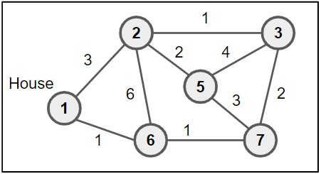

I want to go for a run. I want to go for a long run, starting from my home and ending at my home. And I want the first part of the run to be only uphill, and the second part of the run to be only downhill. I have a trail map of the nearby national park, where each location is represented as a node and each trail segment as an edge. For each node, I have the elevation (value shown in the node). Find me the longest possible run that goes first uphill and then downhill, with only one change of direction.

**Hint:** You might want to turn this into a kind of graph where the previous question can *just be called* on your graph to help compute the correct answer.

**Ans:** We can model this as a more useful graph. We can create two copies of the map where in the first graph, the edges are directed uphill whereas in the second graph, the edges are directed downhill. Connect each node in the first copy with a directed edge to their corresponding node in the second copy. Since the new graph is a directed acyclic graph, we can make use of the algorithm to find the longest path in a DAG, find a topological order of the graph and relax the outgoing edges of each node in order.

**Problem 5.** (A Random Problem with a dude called Dan)

**Problem 5.a.** Dan is on his way home from work. The city he lives in is made up of *N* locations, labelled from 0 to (*N* − 1). His workplace is at location 0 and his home is at location (*N* −1). These locations are connected by *M* **directed** roads, each with an associated *non-negative* cost. To go through a road, Dan will need to pay the cost associated with that road. Usually, Dan would try to take the cheapest path home.

The thing is, Dan has just received his salary! For reasons unknown, he wants to flaunt his wealth by going through a *really expensive road.* However, he still needs to be able to make it back home with the money he has. Given that Dan can afford to spend up to *D* dollars on transportation, help him find **the cost of the most expensive road that he can afford to go through** on

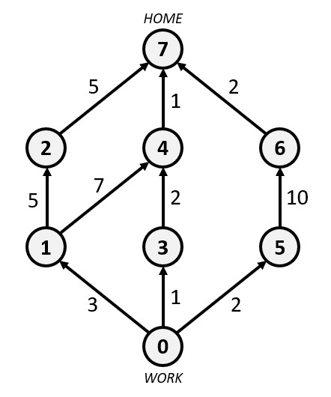

**Figure 1:** Example city 1

his journey back home.

Take note than Dan only cares about the most expensive road in his journey; the rest of the journey can be really cheap, or just as expensive, so long as the entire journey fits within his budget of *D* dollars. He is also completely focused on this goal and does not mind visiting the same location multiple times, or going through the same road multiple times.

For example, suppose Dan’s budget is *D* = 13 dollars. Consider the city given in Figure 1, consisting of *N* = 8 locations and *M* = 10 roads.

The path that Dan will take is 0 → 1 → 4 → 7. In this journey, the total cost is 11 dollars and the most expensive road has a cost of 7 dollars - the road from locations 1 to 4. Therefore, the expected output for this example would be “7”.

Note that this path is neither the cheapest path (0 → 3 → 4 → 7), nor is it the most expensive path that fits within his budget of 13 dollars (0 → 1 → 2 → 7).

There is also a more expensive road within this city - the road from locations 5 to 6 with a cost of 10 dollars. However, the only path that goes through this road, 0 → 5 → 6 → 7, has a total cost of 14 dollars which exceeds Dan’s budget.

**Ans:**

**Problem 5.b.** *(Optional)* Another month, another salary for Dan to flaunt. The situation is similar to that of the previous part.

This time, however, instead of maximizing the cost of the *most expensive road* in his journey, he wants to maximize the cost of *the second most expensive road* in his journey. In other words, he

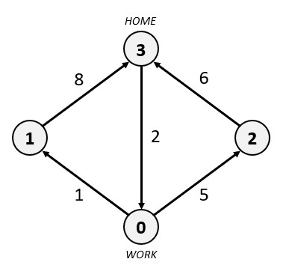

**Figure 2:** Example city 2

no longer cares about the most expensive road in his journey; that road can be 100 times more expensive than the second most expensive road in his journey for all he cares.

For example, consider the city in Figure 2 with *N* = 4 locations and *M* = 5 roads.

If Dan’s budget is *D* = 12 dollars, the path that he will take is 0 → 2 → 3. In this journey, the total cost is 11 dollars and the second most expensive road has a cost of 5 dollars, the road from locations 0 to 2. Therefore, the expected output for this example would be “5”.

Notice that while he can afford to go through the path 0 → 1 → 3 with an expensive 8 dollar road, the second most expensive road in that journey only costs 1 dollar.

If Dan’s budget is *D* = 20 dollars, then the path he will take is 0 → 1 → 3 → 0 → 1 → 3. As irrational as this 20 dollar journey is, it allows him to go through the road from locations 1 to 3

twice, thus making the second most expensive road in his journey cost 8 dollars.